
Fire Detection Electrical Maintenance & Testing Gas Detection
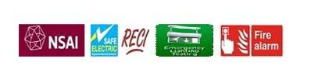
Service Report
Service Type | Electrical Installation Works
Client Name | Paul St Carpark – Cork City Council
Information | Repairs reference Ken/Sean
Date | 09-11-2022
Travel Start Time | 08:00
Travel End Time | 09:00
On Site Time | 09:00
On Site Finish Time | 13:15
Installation Date | 09-11-2022
Customer Name | Ken
Eltech Electrical Services Ltd
Unit 5 Lee Park, Site Cast Industrial Estate, Pouladuff Rd, Cork, T12YP8N
Vat no 6437035J
Tel:021-4289802
Mob:086-6075532
Email: info@eltech.ie
Web: www.eltech.ie

