
Fire Detection Electrical Maintenance & Testing Gas Detection
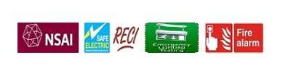
Service Report
Service Type | Technical Service Report
Client Name | Cork City Council –
Information | Cork City Fire Brigade, Anglesea Street
Date | 29-10-2024
Travel Start Time | 10:30
Travel End Time | 10:45
On Site Time | 10:45
On Site Finish Time | 17:00
Customer Name | City council
Eltech Electrical Services Ltd
Unit 5 Lee Park, Site Cast Industrial Estate, Pouladuff Rd, Cork, T12YP8N
Vat No.: 6437035J
Tel: 021-4289802
Mobile: 086-6075532
info@eltech.ie
www.eltech.ie

